Machine Learning to Produce Accurate Accurate 3D images

# Executive Summary

Many biologists now take multi-coloured 3D images of their samples, but the additional axis results in a smear of colours because different wavelengths are dispersed differently (axial chromatic aberration).

I identified what the cause of this is, modelled the nature of the dispersion, and then wrote code to train a Linear Regressor that would be able to correct 3D images across any microscope and all wavelengths.

# Introduction

In the last decade or so a vast range of techniques have emerged to improve 3D fluorescent imaging in biology. Samples can now be made transparent, lenses have adapted to handle large volumes, and now microscopes are able to detect many difference wavelengths of light. This means we can now look at samples in 3D and label many cells with a wide range of colours.

A great example of this is the work done in connectomics (spatially mapping neuronal connections) where individual neurons can be labelled with a unique colour and then we can image in 3D to see where the axons and dendrites go, and to whom they connect. This can be seen in the video below.[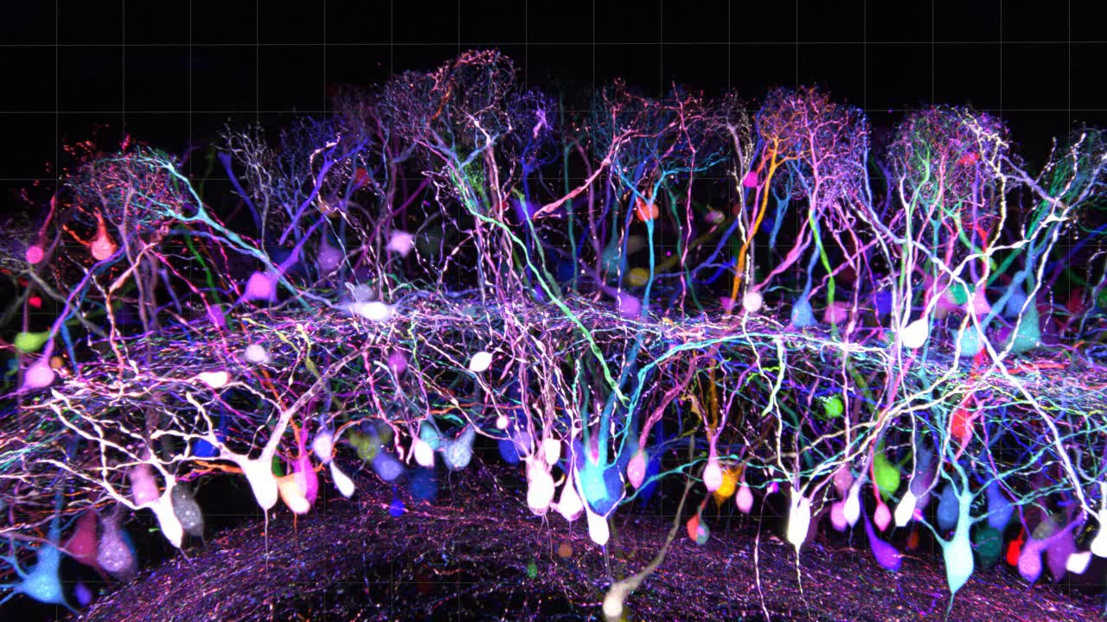](https://www.youtube.com/watch?v=EHato3VVQTs)

Sakaguchi, Leiwe, Imai, eLife 2018

# The problemScreenshot 2023-09-19 at 4.40.47 PM.png

However, while these images are visually stunning there is a major problem. As we all know from high school different wavelengths of light are dispersed when they pass through substances with different refractive indices. Or in other words what you see in a prism, where red and violet wavelengths of light are shifted to different places. In optics this is known as chromatic aberration and there are two forms: longitudinal aberration (XY dispersion) and axial aberration (Z dispersion). This can be seen the the example neuron below which is labelled with 3 different fluorescent proteins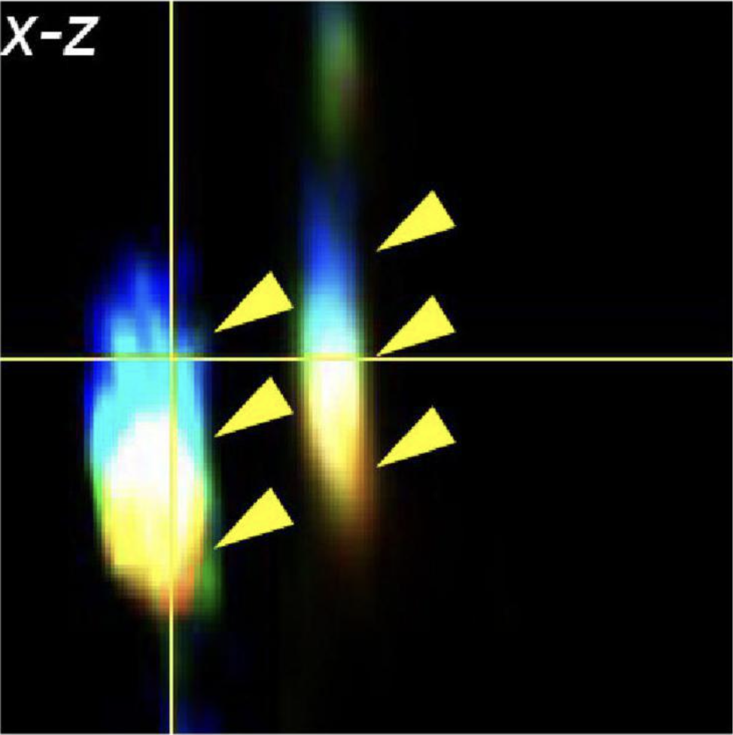 (shown as blue, green, and red), clearly we can see the colour smear in the z-axis (x-z) where the blue colour is significantly higher than the other two colours.

# Exploratory Data Analysis

To investigate this problem, we imaged [Tetraspeck fluorescent microspheres](https://www.thermofisher.com/order/catalog/product/T7279) suspended in agarose. These microspheres are excitable by a wide range of excitation wavelengths, which means that we can measure the effect of chromatic aberration. In short, the fluorescence should be at the same place and any differences in position can be measured as a result of chromatic aberration.

## Pipeline

The challenge here is to go from unstructured 4D data (XYZC images) to a structured database of beads and the chromatic aberration of each colour/wavelength to a reference colour/wavelength. We can split this up into two parts:

1. Detecting the location in XYZ of the beads within the image

2. Measuring the shift of the different wavelengths in XYZ

**Detecting Beads**

Essentially this is a spot detection problem. There are a plethora of solutions available and within this project I designed flexibility. My code can either read in bead locations detected from other spot detection algorithms (e.g. [ICYs Spot detector](https://icy.bioimageanalysis.org/plugin/spot-detector/), or from the [ImageJ ROI manager](https://imagej.nih.gov/ij/docs/menus/analyze.html)), or [my own spot detector](https://github.com/mleiwe/ChromaticAberrationCorrection/blob/master/MeasureChromaticAberration/Subcodes/mnl_AutomaticallySelectBeadLocations.m) which binarises the image (>10SD above the mean), and removes and potential beads that are less than 100 voxels in volume.

For further quality control, I also removed any bead locations where another bead was nearby (doubled , or where the beads were too close to the edge as these could result in aberrant measurements. See the example code block below, the output of which are xyz bounding box co-ordinates.

% Detect beads

[Beads]=mnl_AutomaticallySelectBeadLocations(Data);

% Filter out beads that are too close

[fBeads]=mnl_RemoveDoubleLabelledBeads_BasedOnBeadCenter(Beads,dim);

% Filter out beads that are partly outside the image

[f2Beads]=mnl_RemoveBeadsOnEdge(fBeads,dim);

**Measuring Chromatic Aberration**

How can we measure the chromatic aberration? What I

Now for each bead we can look at a specified bounding box of the image from which we can use to measure the chromatic aberration. The location of each bead is recorded in each channel (colour) by measuring the centre of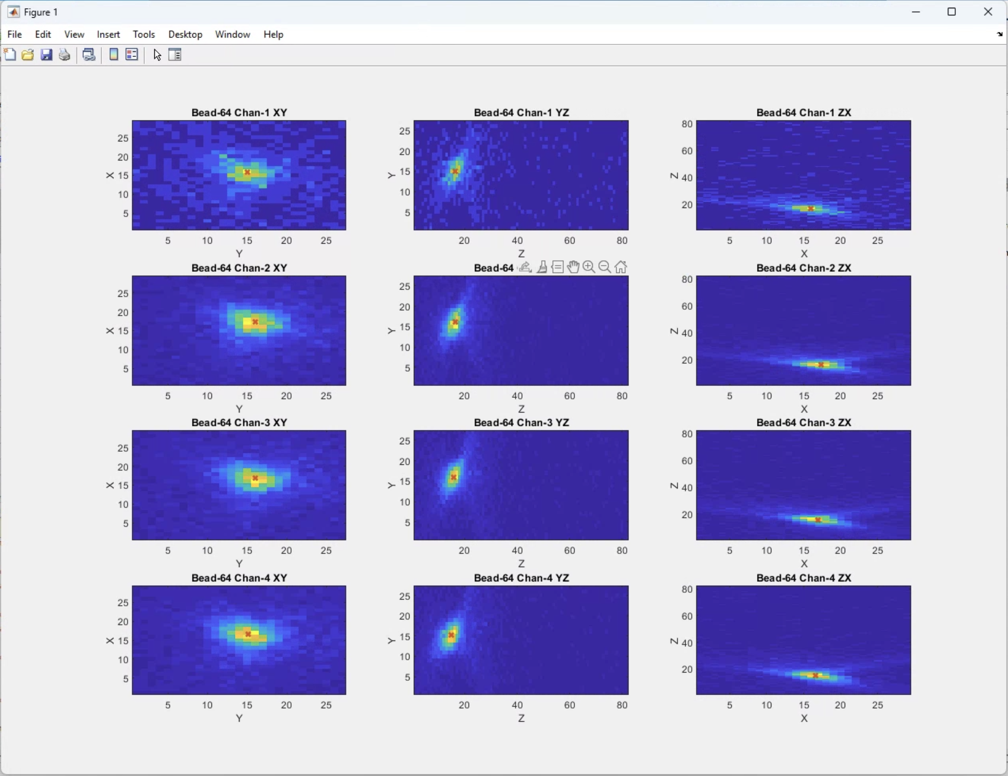 mass according the the intensity of each image. In the example below we have the centre of mass (red cross) recorded for each channel (each row) shown in XY, YZ, and XZ. Now I can measure the distances between each one in X, Y and Z.

I then loop through this analysis for each bead in the image.

However if the volume is large then there are several difficulties. Firstly, the image acquisition time could take much longer (up to 2-3 days). Secondly, the data size would become far too large to be processed locally (>10GB).

Therefore I also adapted the code to allow the user to combin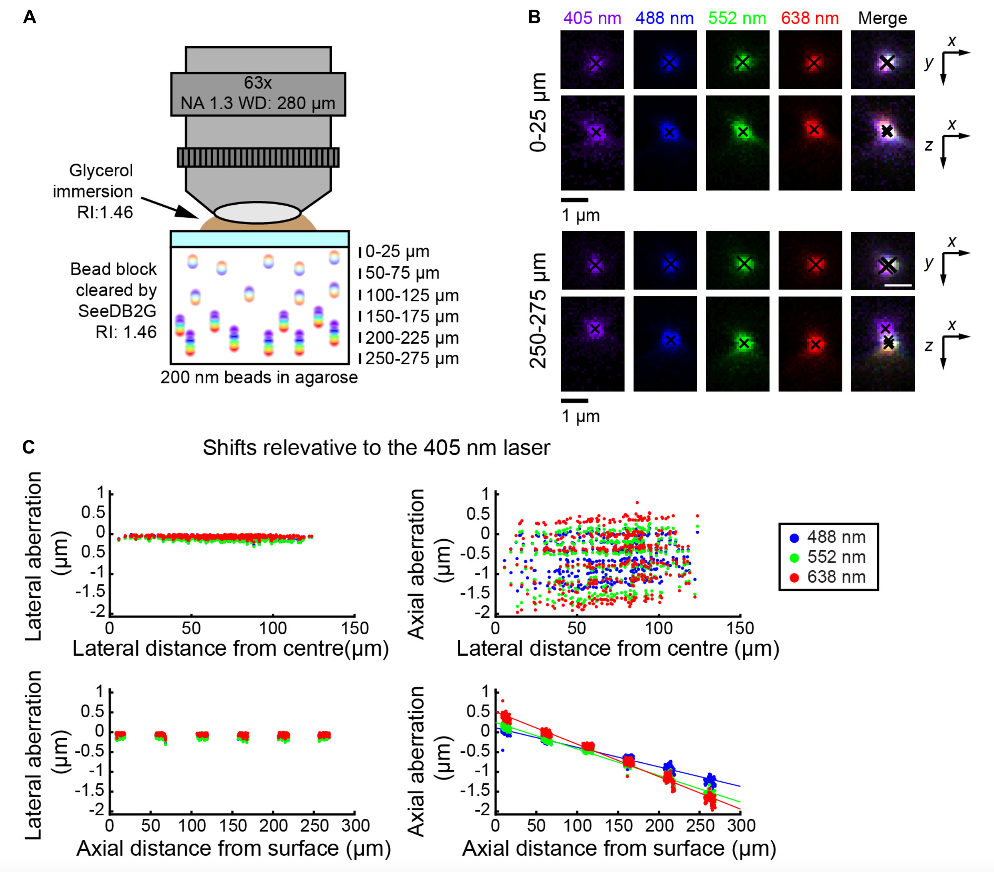e images from different parts of the same sample. In the example below we combined images from 6 different depths and recorded the chromatic aberration. Clearly, there is a strong linear relationship between the depth (Axial distance from surface) and the axial chromatic aberration. This implies that we can predict the aberration that will occur and therefore undo it.

# Solution

To correct for these aberrations we can therefore train a linear regressor for each imaging set up (A) and then predict how much axial aberration will occur to the reference channel. Then we can undo the aberration by shifting the z position of the non-reference channels to their appropriate positions (B).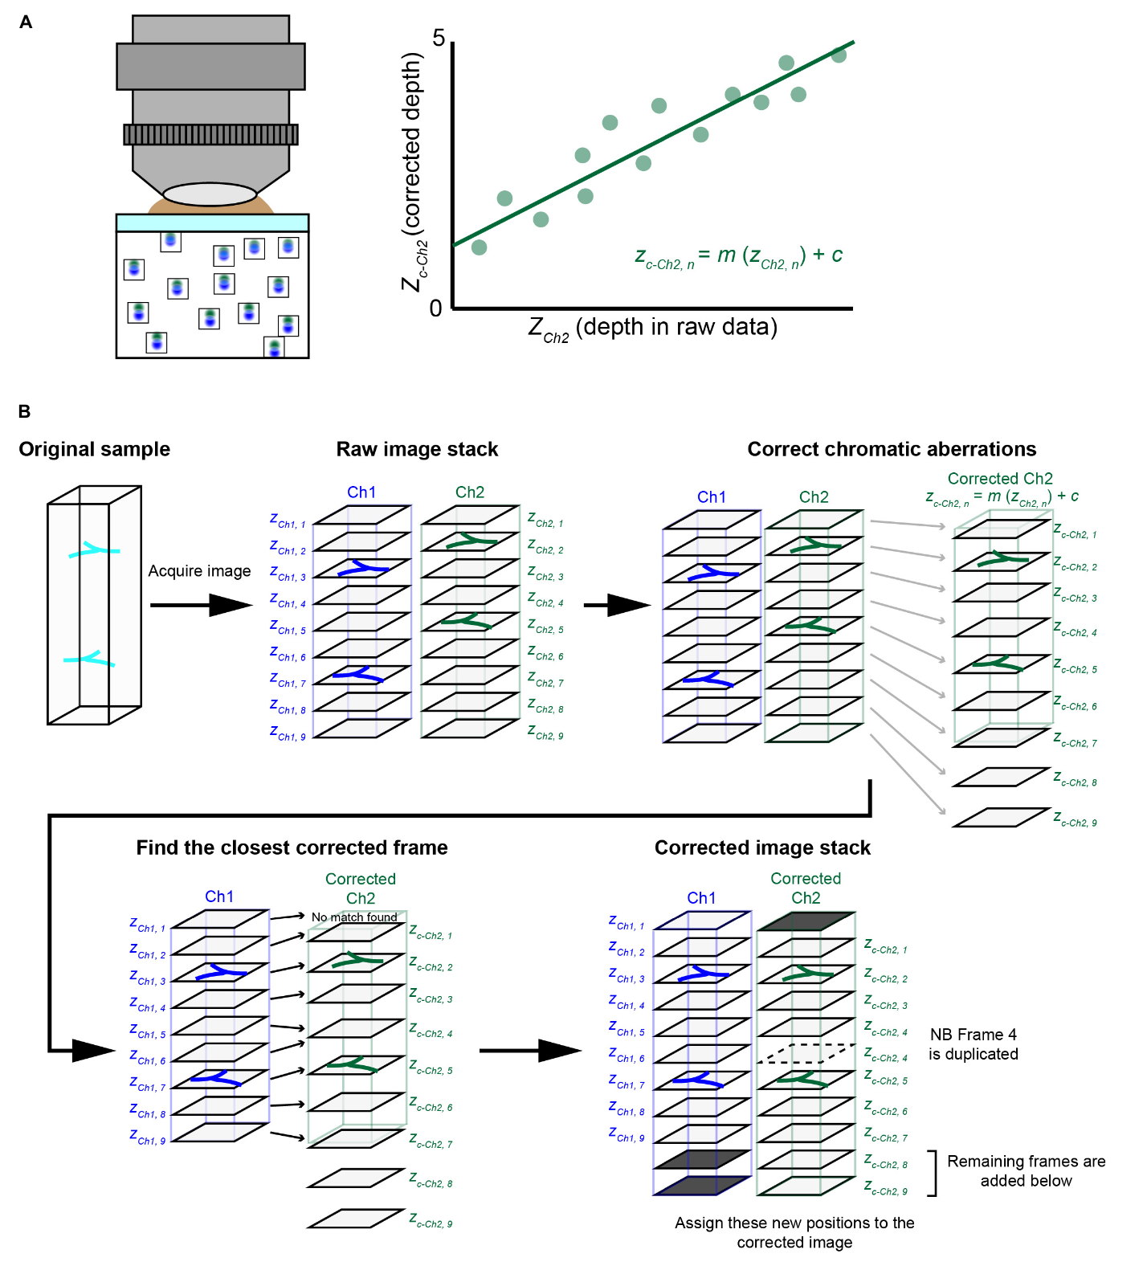

## Training Sets

However, a key question here is how can we train the linear regressor? There are two possible ways in which we can train the regressor.

### Using microspheres to create a ground truth

The most obvious method is to use the same approach as in our EDA. That is for each imaging set up, measure the aberration of a sample of fluorescent microspheres. This should provide high fidelity to train the regressor. As you can see this works for two different microscopes; an Olympus 2-Photon, with a x25 optical lens (A-C), and a Leica confocal with a x63 optical lens (D-F). The key aspect to look are the columns to the right, where in the Before column distinct colours can be seen (yellow arrow heads), while in the after column the colours now are merged (see the single arrowheads).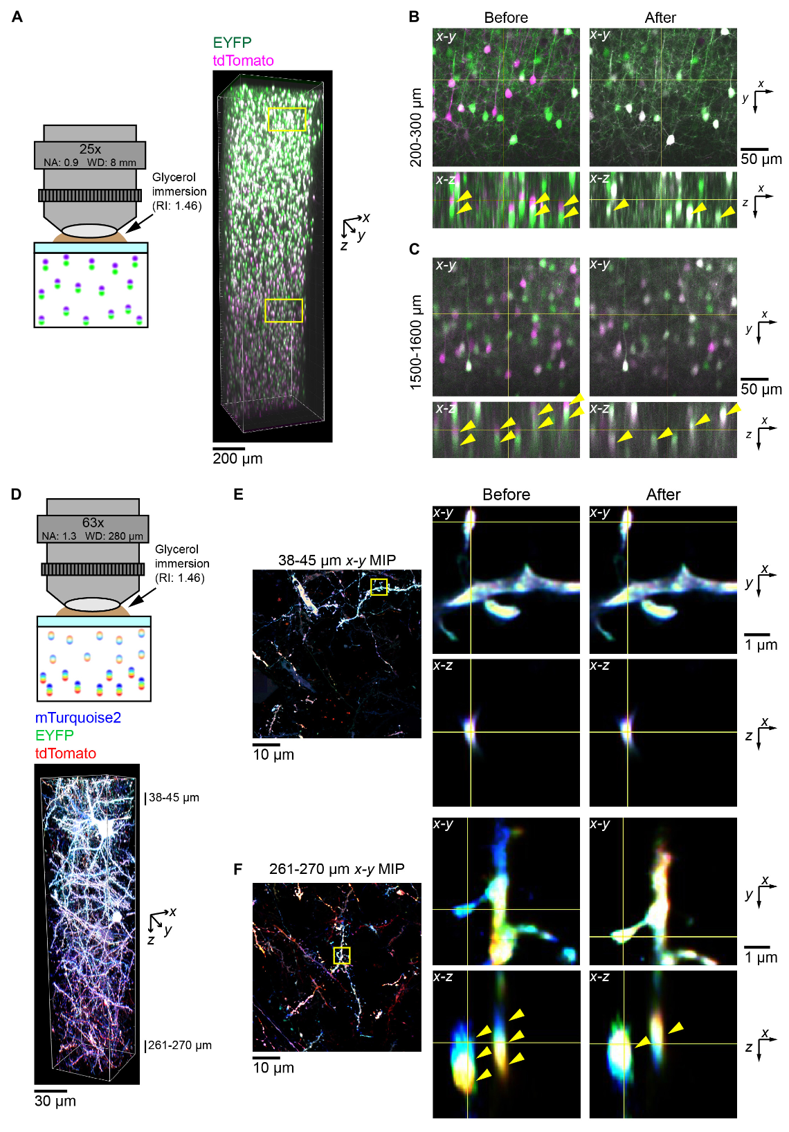

### Using guide stars

While fluorescent microspheres are a very useful solution, often in the real world the data may already be acquired, or a parameter/condition has been changed meaning the trained regressor is no longer valid. What is then required is some sort of post-hoc manner of obtaining data to train the regressor.

Our proposed solution is to use what we termed as “guide stars” but are essentially manually selected parts of the image that are known to contain all the colours at the same point. These can be easily selected, but how many guide stars are needed?

Firstly, in the sample data I selected 15 guide stars, and calculated the r2 values for each regression which were 0.757 and 0.845 for 405-488nm and 405-552nm respectively. Then I selected the lowest value, and used it to calcula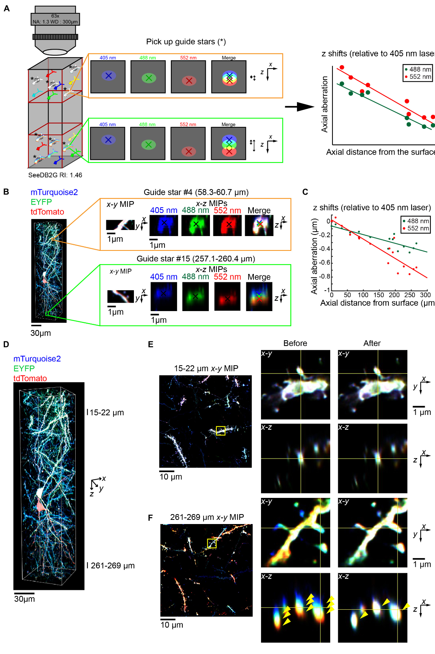te Cohen’s f2, and so calculate the required sample size using G*Power3. This suggested that for this data 7-10 guide stars produced a power of 0.95-0.99 respectively. This technique works just as effectively as the microspheres.